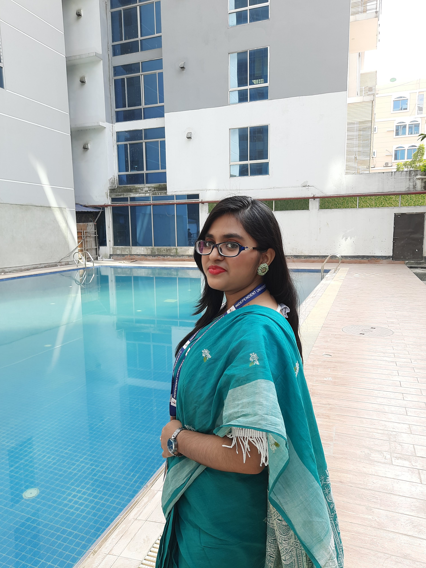

FATEMA MUNJARIN

Work History

Accounting Club in IUB Volunteer (24/04/2023)

* Overview the whole program
* Manage around 200 people
* Take care of everyone

Independent Marketers Association in IUB Program Management Assistant (08/10/2022)

* Manage the whole function
* Manage the programming things

Priyoshop.com, Dhaka Store Assistant (05/05/2022)

* Manage the store
* Count the store items
* Handle the cash counter

 5C Proshanti Tower, 8 Avoy Das Lane, Tikatoli, Motijheel, Dhaka

 01720309345

**✉** fatemamunjarinshifa@gmail.com Skills

* Mother Tongue – Bangla
* Interpersonal – Strong Leadership for group work, Clear Writing, Verbal Communication
* Organisation – Multitasking Ability
* Language Skills – English Skills, Programming Skills, SQL Language Skills
* Job Related Skills – Customer Service, Stock Management, Payment Processing, Cash Handling, Data Entry
* Digital Skills – Microsoft Excel, Office, Email Processing, 65wpm Typing Speed, Github repository

Education Independent University, Bangladesh (IUB) Bashundhara, Dhaka 24/2022 Bachelor of Business Administration: Accounting